# VTS Subsystems Description

## AIS Subsystem

### AIS Base Station SAAB R60

The R60 VDES Base Station from Saab TransponderTech is a VDES compliant base station, including AIS and ASM functionality. It is also prepared for the new VDE channels, pending international approval

The R60 VDES Base Station is the successor to the market-leading R40 AIS Base Station, which assures for high quality and stable performance. Thanks to its market leading Software Defined Radio (SDR) design, it is built to be future proof and support coming changes to international standards and requirements. The R60 is compliant with the RED Directive and applicable international standards such as VDES-standard, AIS Base Station Standard IEC 62320-1, Aton Standard IEC 62320-2 and AIS Repeater Standard 62320-3. The R60 VDES Base Station is the main component of a Physical AIS Shore Station as defined by IALA. Its main purpose is to receive data from and transmit data to AIS/VDES equipped vessels travelling within the coverage area of the Base Station. The R60 can either be installed on a stand-alone basis or integrated into a network, such as the market leading Saab MARITIMECONTROL platform. Ensuring a high degree of reliability and availability has been the key design goal during the development of the R60, resulting in an MTBF better than 100,000 hours. Furthermore, the R60 includes several Ethernet ports to allow for full network connection redundancy and remote power cycling of the base station. The R60 also has a built in NTP-server option to support local time synchronisation for LAN connected equipment. Furthermore, it supports extensive possibilities for VDL analysis via FSR/VSI-message information, giving details such as Received Signal Strength, Time of Arrival and Signal to Noise Ratio. The R60 also supports channel management via both AIS and DSC. To allow for simple monitoring and configuration a colour display with touch interface is available on the front. For more advanced configuration, monitoring and remote updates, there is a built in WEB server

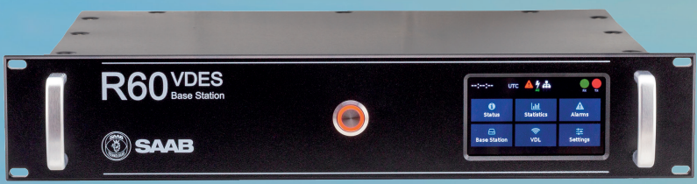

Figure 3‑1 AIS Base Station

|  |  |
| --- | --- |
| **TECHNICAL SPECIFICATIONS** | |
| Type | 19” Rack-mount. Unit height: 2U |
| Dimensions Height | 89 millimetres (3.51”) |
| Width | 483 millimetres (19.02”) |
| Depth | 357 millimetres (14.06”) |
| Weight | 6 kilograms (13 Lbs) |
| Power input requirements | 12-24 VDC, AC 100-240 volts @ 50/60 Hz |
| Recommended fuse size | 20 A (T20A 50VDC) 5x20 mm, 3 A (T3A 250V) 5x20 mm |
| Number of channels | > 50 channels |
| Supported systems | GPS, BeiDou, Galileo, GLONASS |
| Sensitivity | Better than –162 dBm |
| Frequency | L1 (1575 MHz) |
| Update rate | 1 Hz |
| Frequency | 155 – 163 MHz |
| Channel Bandwidth | 25 kHz, future VDE options 50 kHz, 100 kHz |
| Channel Selection | Channel numbers as in ITU-R M. 1084-4 |
| Output power | AIS: LOW (1W) and HIGH (12.5W) |
| Receiver sensitivity | Better than -118 dBm (AIS) and -115 dBm (ASM) at 20% PER |
| Bit rate (Tx/Rx) | 9.6 kbps (AIS), 19.2 kbps (ASM), 307.2 kbps (VDE option max bit rate) |
| Data Ports | RS-232/422 V11. Bit-rate up to 115 200 bps |
| TCP/IP Ports | 3 x Ethernet (UDP, UDP Multicast, TCP). The VDES Base Station supports up to ten simultaneous connections via the Ethernet interface. |
| GNSS-Antenna | TNC-Female, with 5V @ 40mA power supply to GNSS antenna pre-amplifier |
| VHF-Antenna | N-Female, separate RX and TX antenna ports (option) |
| 1PPS and IRIG-B 003 | Via the 9-pin D-sub (male) |
| Digital Input and Output Port | Via the 9-pin D-sub (male) |
| AC-power | IEC 320 connector |
| DC-power | AMP CPC Type III+ |
| Serial data | 9-pin D-sub (male) |
| Temperature | -20°C to +55°C (Operational), -55°C to +85°C (Storage) |
| Humidity | 0-95% |
| MTBF | MTBF is >> TBD hours and availability figure is TBD % |